**Project-Report**

**DOCTOR’S APPOINTMENT**



**Submitted to: Miss Rafia Shaikh**

**By:Shahtaj Alam**

**Maheen Zehra**

**Anum Mukhtar**

**(FA21-BSSE-0075,FA21-BSCS-0102,FA21-BSSE-0096)**

**Date: 30 MAY 2022**

**Department of Computer Science**

##### Muhammad Ali Jinnah University

22-E Block 6, PECHS, Karachi-Pakistan

**1. Introduction:**

The "Doctor Appointment" has been developed to override the problems prevailing in the practicing manual system. This software is supported to eliminate and in some cases reduce the hardships faced by this existing system. Moreover this system is designed for the particular need of the company to carry out operations in a smooth and effective manner. The application is reduced as much as possible to avoid errors while entering the data. No formal knowledge is needed for the user to use this system. Thus by this all it proves it is user-friendly. Doctor Appointment as described above, can lead to error free, secure, reliable and fast management system. It can assist the user to concentrate on their other activities rather to concentrate on the record keeping. Thus it will help organization in better utilization of resources. Every organization, whether big or small, has challenges to overcome and managing the information of Appointment, Doctor, Booking, Doctor Schedule.

**2. Problem Statement:**

Doctor Appointment is used for solving the purpose for disallow the problems, which are not in the current system. This Doctor Appointment System is assuming to remove the hardships, which will be available in the current appointment system. But by using electronics equipment like computer and by using these devices we can stored valuable information which we can stored under this appointment system. This Doctor Appointment is show as the fast, error free and secured system with fast management of data.

**4. Project Description:**

* **Libraries/Procedure/technics:**

The following libraries are used in the project

* #include <iostream>
* #include <stdio.h>
* #include <stdlib.h>
* #include <conio.h>
* #include <string.h>

Moreover we have used following functions as procedures in the project

void Doctor_information(void),void Patient_Appointment(void) and void exist(void).

**5. Real Life Application of your project:**

The following are the applications of our project

1. Patient Administration System (PAS)
2. Operating Theatre Management System
3. Laboratory Information Management System
4. Booking Management System
5. Appointment Management System

**6. Results:**

**(output snappits)**

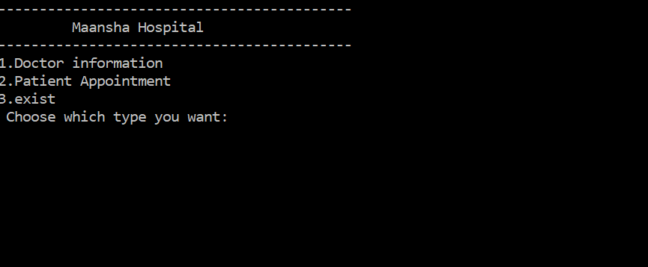

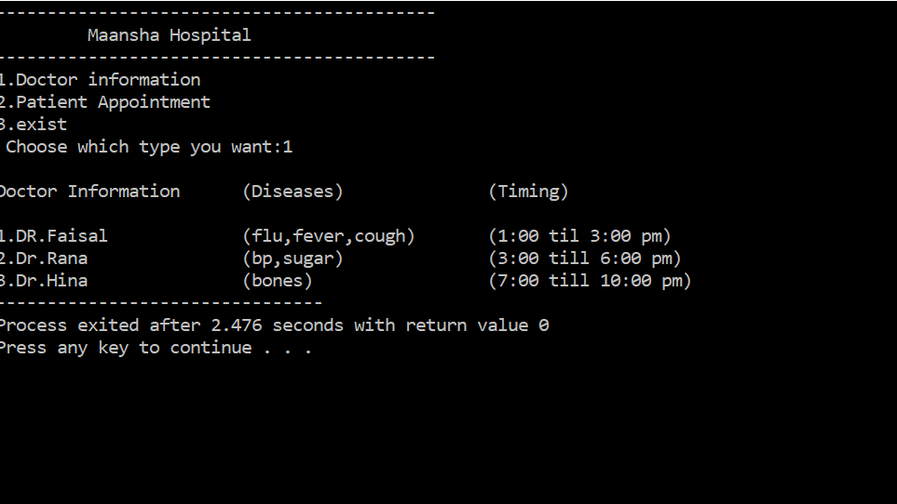

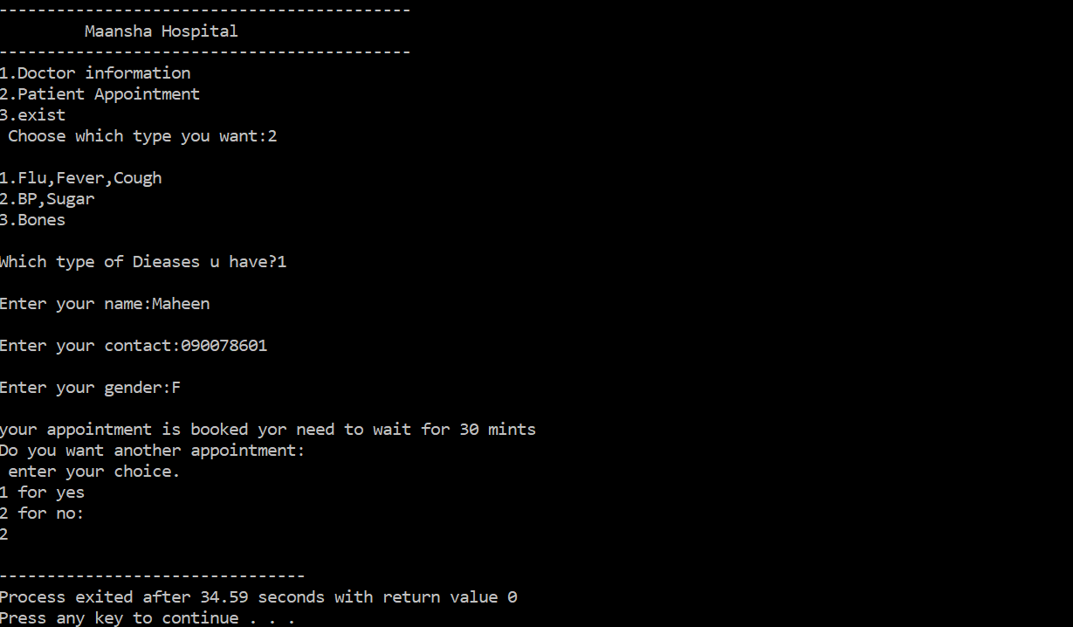

**7. Conclusion:**

The proposed project is a smart appointment booking system that provides patients or any user an easy way of booking a doctor’s appointment online. This is a web based application that overcomes the issue of managing and booking appointments according to user’s choice or demands. The task sometimes becomes very tedious for the compounder or doctor himself in manually allotting appointments for the users as per their availability.